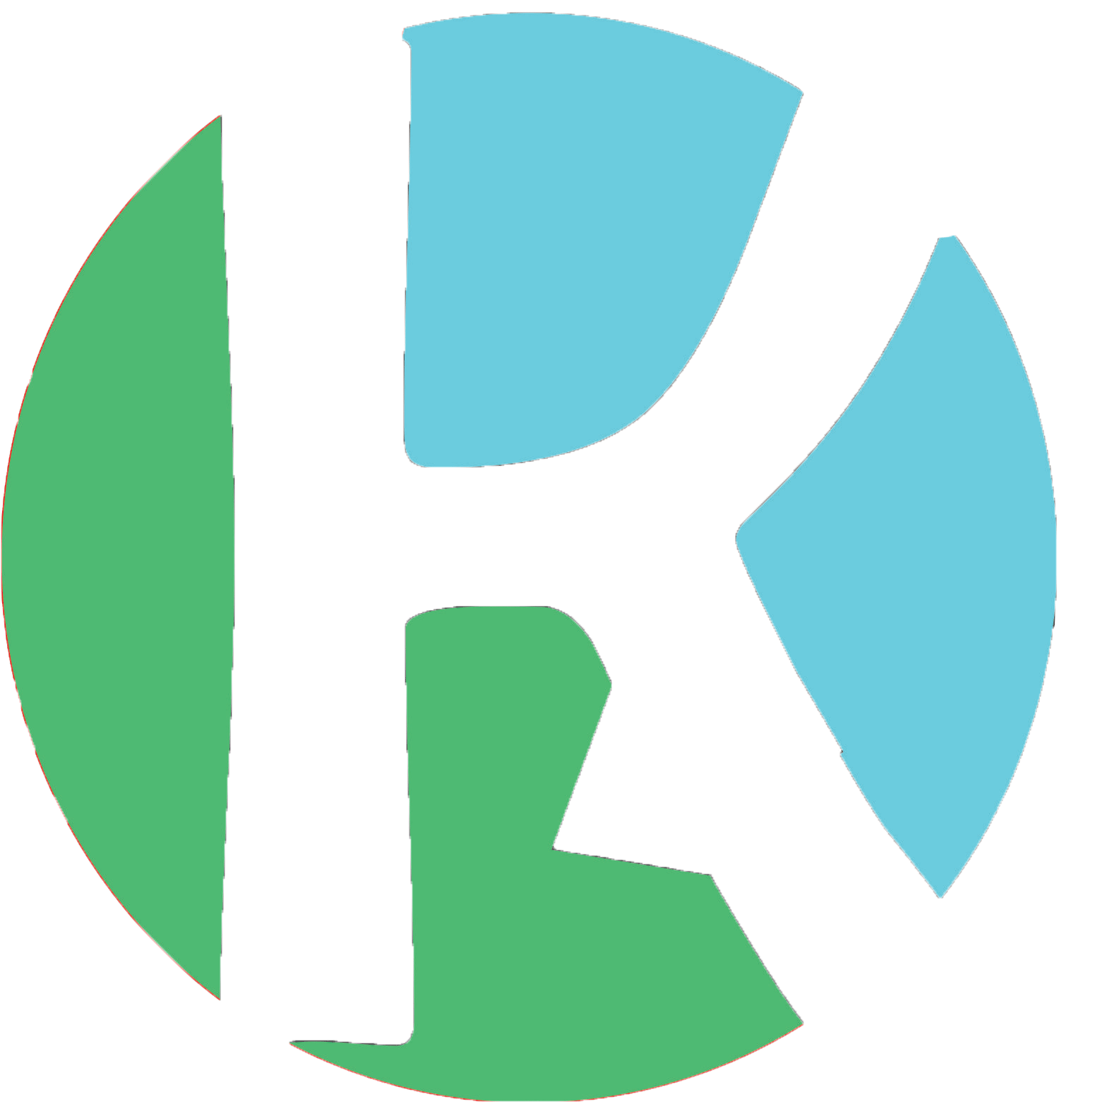KODAH INC.

ABOUT THE APP FOR PLAYSTORE .

Don’t know when the next shuttle will arrive? Are you indecisive as to whether to walk or wait for the shuttle? KODAH INC comes your way with the locate KNUST app.No need to sign up or any long registration process.With just a single click you can enjoy the exciting features of this app.Know when the shuttle will arrive with a single click.